**RALAZABA Electronics**

**Weekly Report**

**Team Members:** Ali AYDIN, Anıl AYDIN, Enes AYAZ, Nail TOSUN, Selman DİNÇ

**Advisor:** Lale ALATAN

|  |
| --- |
| **Done** |
| **To Do** |

|  |
| --- |
| **Kalman Filter Road-Map**  At the conceptual design report, we proposed 5 different ways to sense the robot’s localization. We chose two methods together in order to prevent cumulative errors at the location and heading angle. Therefore, we decided to use a Kalman filter. In order to use a Kalman filter, we should have two measuring methods one is more accurate less frequent other one vice versa.  Our method to sense position are two mouses method and encoder reading. To measure how much cumulative error can cause problems at the robot’s operation we wrote a test procedure for two mouse method. Our first thought is the mouse method has better accuracy but sensor data less frequent. The encoder readings are real-time but noisier. However, calculation errors of both two methods are crucial for filter design.  This week, we measure the error of two mouses method. Following week, we will test the encoders.  **C:\Users\nailt\AppData\Local\Microsoft\Windows\INetCache\Content.Word\Kalman_filter.png** |

Figure 1 Kalman Filter Block Diagram

|  |
| --- |
|  |

**Self-localization (State Observer) Test Procedure**

**Test Plan**

We want to use the 2 mouse method to solve the self-localization problem. In this method 2 separate mouse’s combined to measure both relative distance and heading angle of the robot. To measure errors of this method we planned a test plan.

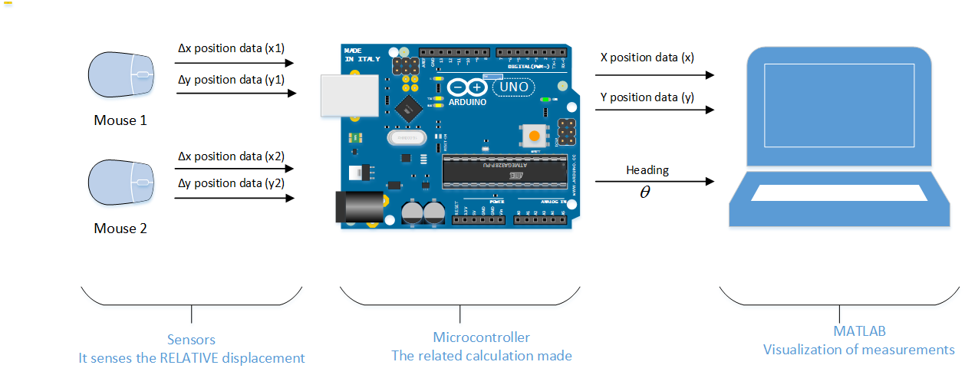

Figure 2 Block Diagram of the Test Plan

**Test Setup**

We read the sensor data with Arduino Nano. The related calculations made at MATLAB and Arduino environments. We measure the ground truth using millimetric papers.

**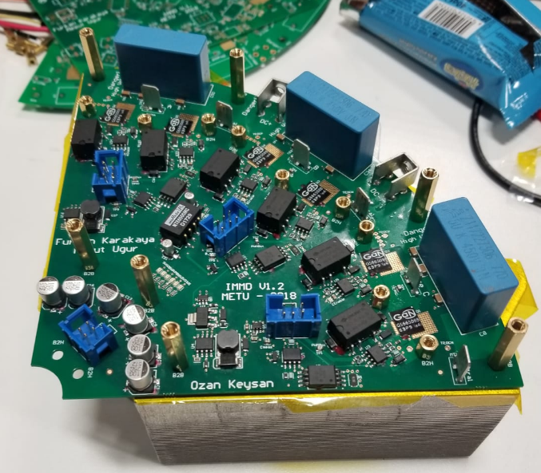**

Figure 3 Test Setup

|  |  |
| --- | --- |
| **Test** | **Expectation** |
| Straight Line 1 at a small distance () | Is the unit measure the distance with MEA less than %1? |
| Straight Line 2 at large distance () | Is unit measure the distance with MEA less than %1  Is the effect of cumulating the error seen? |
| 2 Direction movement at an acute angle  ($θ<90 °$) | Is the unit measure the heading angle with MEA less than 1 ? |
| 2 Direction movement at a wide angle  () | Is the unit measure the heading angle with MEA less than 1 ?  Is the effect of cumulating the error seen? |
| Arc (Quarter circle) | Is the unit measure the final destination with MEA less than %1?  Is the unit measure the heading angle with MEA less than 1 $°$? |

Table 1: Test Procedure

**Test Results**

**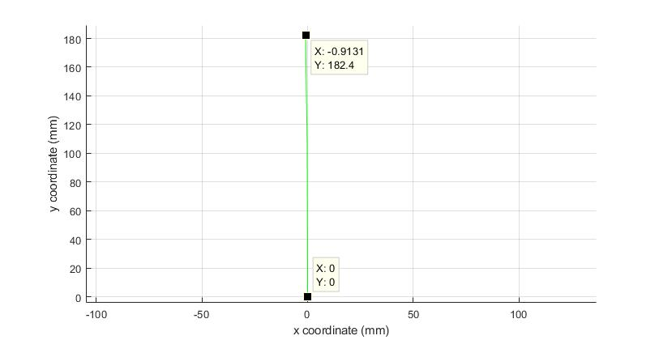**

Figure 4: Test 1 short distance measurement

|  |  |
| --- | --- |
| **C:\Users\nailt\AppData\Local\Microsoft\Windows\INetCache\Content.Word\1.jpeg**  Figure 5: Test 2 Long distance measurement | **C:\Users\nailt\AppData\Local\Microsoft\Windows\INetCache\Content.Word\2.jpeg**  Figure 6: Test 3 Small heading angle |

|  |  |
| --- | --- |
|  | **C:\Users\nailt\AppData\Local\Microsoft\Windows\INetCache\Content.Word\4.jpeg**  Figure 7: Arc Test |

**Errors**

|  |  |  |  |
| --- | --- | --- | --- |
| **Test No** | **Ground Truth** | **Measurement** | **Error** |
| 1 |  |  |  |
| 2 |  |  |  |
| 3 |  |  |  |
| 4 |  |  |  |
| 5 |  |  |  |

**Conclusion**